Programme
Module name
Student Reference Number (SRN)
Report/Assignment Title
Date of Submission
(Please attach the confirmation of any extension received)
Declaration of Original Work:
- I hereby declare that I have read and understood BPP’s regulations on plagiarism and that this is my original work, and that I have researched, undertaken, completed and submitted in accordance with the requirements of BPP School of Business.

- I declare that where I have used any AI tools, it was for the following reasons (highlight as appropriate):
o To review a draft o To correct language errors o Other (please describe)
_______________________________________________________
- I have copied & retained for BPP University’s reference, all AI prompts used in the creation of AI content and all AI-generated responses in support of my assignment and attached relevant evidence in the appendices.

- I understand that I may be required to participate in a viva voce, where I will be questioned on any aspect of my assignment, including key concepts, theories, examples used, & any sources included.

- The word count, excluding contents table, bibliography and appendices, is ___ words.
Student Reference Number: Date:
By submitting this coursework you agree to all rules and regulations of BPP regarding assessments and awards for programmes. Please note, submission is your declaration you are fit to sit.
BPP University reserves the right to use all submitted work for educational purposes and may request that work be published for a wider audience.
BPP School of Business

MSc Management

Organisational Strategy and Sustainability

Shivam Cement: Strategic Evaluation and Analysis

Table of Contents
1. Introduction 5
2. LO1: Strategic Environmental Analysis 5
2.1 Internal Environmental Analysis (VRIO Framework) 5
2.1.1 Internal Environmental Analysis (VRIO Framework) – Global Context 5
2.2 The External Environmental Analysis (PESTEL Framework) 7
2.3 SWOT Analysis and Suggestions: 9
3 LO2: Ethical, Sustainable and Responsible Practices 10
3.1 Corporate Social Responsibility (CSR) 11
3.1.1 People: 11
3.1.2 Planet: 12
3.1.3 Profit 13
4 LO3: Analysis of Strategic choices within a Worldwide Multifaceted System 14
4.1 Strategic Models 14
4.1.1Ansoff's Matrix: 14
4.1.2Market Penetration 14
4.1.3 Market Development 15
4.1.4 Product Development: 15
4.1.5 Diversification 16
5 LO4: Personal Leadership and Sustainability Perspective Reflection use only one transformational model you have applied more than this. 17
5.1Shivam Cement Leadership Insights 17
5.2 Leadership Development on a Personal Level 18
5.3 Future Career Aspirations 18
Conclusion 19
References 20

Strategic Evaluation of Shivam Cement: Strategy, Sustainability, and Leadership

1. Introduction
Shivam Cement Ltd is a large manufacture of cement in Nepal cement industry that strives to produce a high-quality cement product in a sustainable manufacturing process. The report is an analysis of the corporate strategy, sustainability, and leadership at Shivam Cement. The report gives an in-depth assessment of its position in the market and potential in the future using theoretical frameworks, which include VRIO, PESTEL, and TBL.

2. LO1: Strategic Environmental Analysis
This part will use the VRIO and PESTEL frameworks to assess the strategic position of Shivam Cement. These models evaluate the internal capabilities of the company and examine external forces which affect the operations and the strategic choices of the company.

2.1 Internal Environmental Analysis (VRIO Framework)
The internal environment of the Shivam Cement is based on the key resources and capabilities of the company. With the aid of the VRIO framework (Value, Rarity, and Imitability, Organization) one can take these aspects into account.

2.1.1 Internal Environmental Analysis (VRIO Framework) – Global Context
The internal environment of Shivam Cement is determined by its key resources and capabilities. The VRIO framework (Value, Rarity, Imitability, Organization) can be used to identify these aspects.
Valuable:
As compared to the competitors who import raw material to make production, the limestone reserves at Shivam lower the costs (Khalil and AbouZeid, 2025; Nepal News, 2024; myRepublica, 2024; Shivam Cement, 2025). German vertical mills with reduced energy consumption, waste-heat recovery, automated production lines can reduce the cost of operation and increase the environmental performance (Shakya et al., 2025; UNFCCC, 2023; Global Cement, 2024; Shivam Cement, 2025). These assets allow it to lead the cost and be greener in Nepal, the broader Asian market, and prospective EU/NA export markets (Times of India, 2024; EU Taxation and Customs Union, 2025; S&P Global, 2024).
Rare:
Carbon capture technologies and alternative fuels are the factors that make Shivam superior to Nepalese and other regional competitors (Ige et al., 2024; Global Cement, 2024; Shivam Cement, 2025). There are examples of green demand in Asia such as in India, where LC3 low-carbon cement and other projects are active (Times of India, 2024). Adherence to EU policies, such as the Carbon Border Adjustment Mechanism (CBAM), makes Shivam competitive to differentiate in the European markets (EUR-Lex, 2022; European Parliament Think Tank, 2022; European Parliament, 2025; Council of the EU, 2022; Industry/Market Analysis, 2022; KPMG, 2023; Shivam Cement, 2025).
Imitable:
Although they are capital-intensive technologies, replication can be achieved with time, and such technologies need specialist skills (Santos et al., 2024; Time Magazine, 2024; Shivam Cement, 2025). Nevertheless, green cement early adoption and good branding minimise the short-term imitability in the Nepal, Asian, and international markets (Global Cement, 2024).
Organized:
The sustainability and innovation are internalized in the operations by the leadership and organizational structures, so that the resources are optimally used (Kumari and Joshi, 2025; FNCCI, 2023; Aryal, 2025; Shivam Cement, 2025). The company culture has a sustainability component, and it is aligned to the international ESG requirements and is ready to be export orientated to EU and North America (Nepali Times, 2021; Cemnet, 2025; Shivam Cement, 2025).

2.2 The External Environmental Analysis (PESTEL Framework)
PESTEL framework assists in evaluating the external forces that shape the strategy of Shivam Cement.
- Political: Nepal suggests incentives of tax exemption and green policy. Exporting is limited however by trade barriers, including the EU Carbon Border Adjustment Mechanism (CBAM), which levies carbon tariffs on imported cement, and country-based tariffs in India and Bangladesh to protect local manufacturers, which increases the cost of expansion into the region. CBAM is already impacting the trade flows in cement and the high carbon-intensive exporters are subjected to regulations in EU (Nepal News, 2024; EUR-Lex, 2022; Financial Times, 2023; Global Cement, 2022; Global Cement, 2025; CEMBUREAU, 2022; Shivam Cement Ltd, 2025).
- Economic: The increasing infrastructure development in Nepal and Asia will offer growth opportunities. However, fluctuating fuel and raw material prices, inflation and currency devaluation in Nepal, and excess capacity in Asian markets are threats to the profitability and will need dynamic cost and supply control. Export revenue can also be impacted by CBAM and trade barriers which require nimble financial and operations plans (Nawaz et al., 2020; Times of India, 2024; ECIPE, 2022; Shivam Cement Ltd, 2025).
- Social: There is growing demand of eco-friendly cement all over the world. Low-carbon and LC3 cement can be adopted in Nepal, Asia, and NA because of the opportunities offered by the implementation of green building standards and customers who are conscious of sustainability. Lower CO2 footprints are becoming more popular among the consumers and institutional buyers of cement in the US and Europe (Santos et al., 2024; Time Magazine, 2024; Nepal News, 2024; WRI, 2024; Shivam Cement Ltd, 2025).
- Technological: The production lines are automated and efficient in saving energy by using less energy to produce cement in Shivam Cement. The AI-based process optimisation, carbon capture, and alternative fuel technologies in NA and EU plants are the world leaders, and only constant investments can keep them competitive. Investments in technologies of a low-carbon cement by the U.S. DOE represent an evidence of the technological competition in the achievement of the sustainability of production (Viardot, 2025; Time Magazine, 2024; WRI, 2024; Shivam Cement Ltd, 2025).
- Environmental: Cement production is carbon intensive and is regulated on a global level. The carbon-neutral fuel and alternative energy source adopted by Shivam is in line with what is required worldly, but the EU carbon reporting, renewable energy requirement, and the lifecycle analysis requirement require more innovations. The use of blended cement and alternative fuels in NA and EU dictate the global principles of environmental compliance (Ige et al., 2024; EUR-Lex, 2022; UNFCCC, 2023; WRI, 2024; Shivam Cement Ltd, 2025).
- Legal: It is imperative to comply with the environment, labor and ESG standards. The markets in the EU and NA have strict-carbon reporting and product certification requirements before export, and the regulations of Nepal control the local environmental effects. The reporting requirements set by the EU CBAM and US regulatory systems guarantee that carbon-intensive industries comply with the law (Khalil and AbouZeid, 2025; FNCCI, 2023; Global Cement, 2025; Shivam Cement Ltd, 2025).

2.3 SWOT Analysis and Suggestions:

Strengths (VRIO) | Weaknesses (VRIO)
Ownership of limestone mines reducing import reliance; early adoption of sustainable technologies (carbon capture and alternative fuels); strong eco-branding are sources of competitive advantage. | High capex dependency for tech upgrades; limited export capability due to trade barriers; reliance on local energy and logistics infrastructure.

Opportunities (PESTEL) | Threats (PESTEL)
Rising demand for low-carbon/LC3 cement; infrastructure growth across Asia; incentives for green production; AI optimisation; entry into NA via sustainability partnerships. | EU CBAM carbon tariffs; regional tariff protection (India, Bangladesh); fuel price volatility; stricter ESG compliance; global tech race; currency fluctuations.
- Invest into AI-based process optimisation and lifecycle carbon reporting to align with global regulations and get operations more efficient (Sandbhor et al., 2023).
- Seek strategic collaborations or partnerships in Asia and North America so as to avoid tariff barriers and improve market entry skills (Gao et al., 2024; Wu et al., 2024).
- Use long-term contracts of sourcing energy and raw materials to reduce the fluctuations of fuel prices and currency (Tsai & Lin, 2024).
- Use Shivam technology leadership on sustainable technology to differentiate products as high-carbon cement in premium low-carbon in high-regulated export markets (Ahalawat & Sethi, 2025).

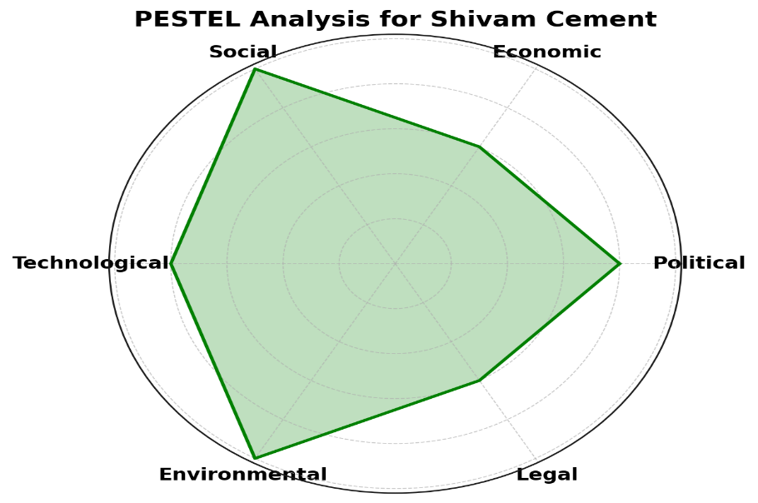
Figure 1: PESTEL Analysis for Shivam Cement
This radar chart illustrates the key external factors affecting Shivam Cement, with particular emphasis on Social, Environmental, and Technological influences. Adapted from (Anchan et al. 2024) from Vilakshan-XIMB Journal of Management, and (Khalil and AbouZeid, 2025) from Construction Materials.

3 LO2: Ethical, Sustainable and Responsible Practices
Under this section, the corporate social responsibility practices (CSR), sustainability practices, and an ethical leadership style of Shivam Cement were evaluated on the foundations of the following frameworks, including the Triple Bottom Line (TBL) in an attempt to estimate the net impact of the practices on the society, the environment, and profitability.

3.1 Corporate Social Responsibility (CSR)

3.1.1 People:
Shivam Cement is a company that is highly concerned with the corporate social responsibility (CSR) and dwells on the community development, the environmental sustainability, and the education. The company funds local education programs offering scholarships to students in the local areas and increases the image of the company as a socially responsible organization (Shivam Cement Ltd., 2024). Furthermore, Shivam puts money in healthcare, such as medical camps, which directly affect the community positively and enhance the image of the company in terms of ethical conduct.
The company deals with the customers in the form of direct advertisement as in the case of the TV commercial series of No Compromise TV commercials, which present the quality and sustainability pledge of the company, which enhances the trust and brand loyalty (Shivam Cement Ltd., 2025). The other area that Shivam focuses on is staff motivation since it is trained about sustainability and safety periodically, the corporate culture of environmental consciousness and staff development is promoted.
Shivam Cement has an active dialogue with the stakeholders through regular meetings where business is transacted as per the expectation of the community and the provisions of the regulations. This collaboration improves its relations with suppliers, customers as well as government agencies.
UN Sustainable Development Goals (SDGs) specifically SDG 4 (Quality Education), SDG 8 (Decent Work and Economic Growth) and SDG 12 (Responsible Consumption and Production) are in line with the CSR activities of Shivam (Shivam Cement Ltd., 2024). The initiatives also help in the compliance to the EU environmental regulations and the expansion of the Shivam Cement into the European, Asian and North American markets and the latter where the sustainability rates are higher.

3.1.2 Planet:
Shivam Cement has also made a massive investment in the area of csr and it has become a leader in the green manufacturing within the cement sector (Shivam Cement Ltd., 2024). The firm has adopted numerous practices that are environmentally friendly to reduce its effects on the environment (Ige et al., 2024). It is also important to note that Shivam has embraced the utilization of alternative fuels in their production process that has seen them replace fossil fuels with waste materials and biomass that has significantly minimized carbon emission.
The company also has an interest in the green cement technologies that utilize the clinker substitutes thereby reducing the cost of production on environment. These events are correlated to the level of world csr and contribute to the mission of the Shivam Cement which is to become a carbon-neutral company by using carbon capturing technologies (Khalil and AbouZeid, 2025). The innovations would see the company not only abide by the local level of environmental rules and regulations but also global ones and consequently enhance its reputation as a business that embraces the concept of csr.
Furthermore, the decision by Shivam Cement to minimize waste and adopt more energy-efficient procedures is in line with its long-term goal of environmental sustainability (Shivam Cement Ltd., 2024). The emphasis of the company on conservation of resources bases it to compete with other companies who increasingly follow the trend of using environmentally-friendly products. This project is in line with UN Sustainable Development Goals (SDG 12: Responsible Consumption and Production) whereby it makes its production processes more resource efficient and also in line with the EU environmental regulation of limiting carbon emissions and promoting sustainability. The fact that Shivam is also committed to producing eco-friendly products also confirms its potential to expand to other global markets in EU, Asia, and North America, where there is increased demand of low-carbon and sustainable building materials (Khalil and AbouZeid, 2025).
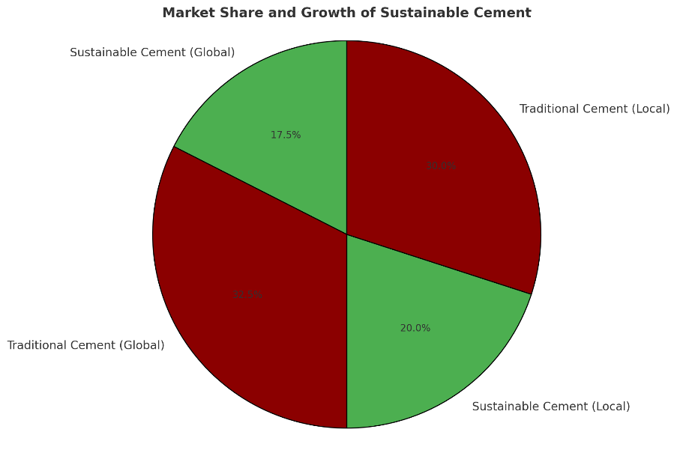
Figure 2: Market Share and Growth of Sustainable Cement
This pie chart represents the market share of sustainable cement versus traditional cement in global and local markets, demonstrating the rising demand for eco-friendly cement products. Adapted from: (Anchan et al. 2024) from Vilakshan-XIMB Journal of Management, (Ige et al. 2024) from Clean Technologies and Environmental Policy, and (Khalil and AbouZeid, 2025) from Construction Materials.

3.1.3 Profit
The significant increase in the Shivam Cement within the years of 2023-2025 when it is expected to reach 1.045 billion in net profit directly contributes to the rise in satisfaction of the shareholders since it will improve the earnings, as well as the financial background (Shivam Cement Ltd., 2024). Through this accomplishment, the company is aligned with the UN Sustainable Development Goals (SDGs), SDG 8 (Decent Work and Economic Growth) and SDG 12 (Responsible Consumption and Production) regarding the creation of jobs and the production that is sustainable (Anchan et al. 2024). The high profitability will allow Shivam to satisfy the EU environmental standards and enter the Asian, EU, and North American market where sustainability credentials are a must to enter the market and are selected by customers, further increasing its presence in the world (Santos et al., 2024).

4 LO3: Analysis of Strategic choices within a Worldwide Multifaceted System
In this section, strategic choices of Shivam Cement will be assessed in terms of the Ansoff Matrix and Porters Generic Strategies. These models can give an understanding of the possible growth strategies and most appropriate direction of staying ahead in the competitive global market.

4.1 Strategic Models

4.1.1Ansoff's Matrix:
Ansoff Matrix is a strategic analysis tool that can be used to find the opportunities that can be exploited to grow Shivam Cement. A framework can assist Shivam to examine its opportunities based on leveraging on existing products, new markets, and new innovations by assessing four key strategies which include Market Penetration, Market Development, Product Development and Diversification (Khalil and Abouzeid, 2025). The two expansion strategies present distinct opportunities of growth in Nepal, the Asian market, EU, North America, where the global market reveals increased interests in sustainable construction materials and other inventions that are nature-friendly.
Ansoff Matrix has four broad growth strategies that include Market Penetration, Market development, Product Development and diversification. Shivam Cement can expand in a number of opportunities.

4.1.2Market Penetration
Shivam Cement has an opportunity to gain market share in Nepal through competitive pricing strategy that is, offering low quality products at low price (Wawaka, 2018; Tahat, 2023). The use of its mobile application to help customers place their orders easily and monitor their deliveries makes them also comfortable with the company (Shivam Cement Ltd., 2025). The physical stores and distributor outlets of Shivam are well distributed, which ensures good delivery. Its marketing strategies are to conduct certain marketing campaigns like the No Compromise on Quality that emphasized on green cement and environment-friendly production to attract those that are green conscious (Santos et al., 2024).
The solution is also sustainable construction materials because Shivam will be able to meet the growing demand in terms of sustainable construction materials with its green cement and energy-efficient technologies, which would be applicable to diversify its offer in the domestic market (Santos et al., 2024).

4.1.3 Market Development
This is one of the strategies that Shivam Cement has not fully incorporated (Shivam Cement Ltd., 2024). The adjacent markets like India and Bangladesh have a high cement demand rate as the rate of infrastructure development is high and Shivam Cement can take advantage of the markets. Shivam Cement will be in a position to differentiate in such markets by taking advantage of the green technologies and sustainable production of cement (Khalil and Abouzeid, 2025). However, the problem of local regulations and the competition on the market ought to be touched upon.

4.1.4 Product Development:
The developed products of Shivam Cement are mainly the traditional types of cement like OPC and PPC with the focus laid on the quality and performance (Shivam Cement Ltd., 2024). The product development especially in the development of the green cement products is one of the areas that can involve Shivam Cement. It entails researching and developing new cement formulations and green alternatives that have an even lower effect on the environment (Viardot, 2025). As the market remains active in the sustainable building materials segment, Shivam will be able to dominate this segment, and the new products like carbon-neutral concrete can be deployed.

4.1.5 Diversification
Diversification is not the most common strategy pursued by Shivam Cement at the moment (Shivam Cement Ltd., 2024). Nevertheless, new growth opportunities could be achieved by entering the renewable energy or green building materials. In such parts as EU, Asia, and North America, the demand in sustainable products is increasing due to legislation, such as EU Green Deal and the Carbon Border Adjustment Mechanism (CBAM), which promotes the low carbon technologies (EUR-Lex, 2022). Eco-friendly construction products also have opportunities in Asia and North America and are in line with the global sustainability objectives (Ge et al., 2023). Nonetheless, diversification is dangerous, including the massive investments in new technologies and the difficulties of operating in the regional regulations (Wu et al., 2024). Nevertheless, in these areas, the prospects of expansion in the long term remain high.
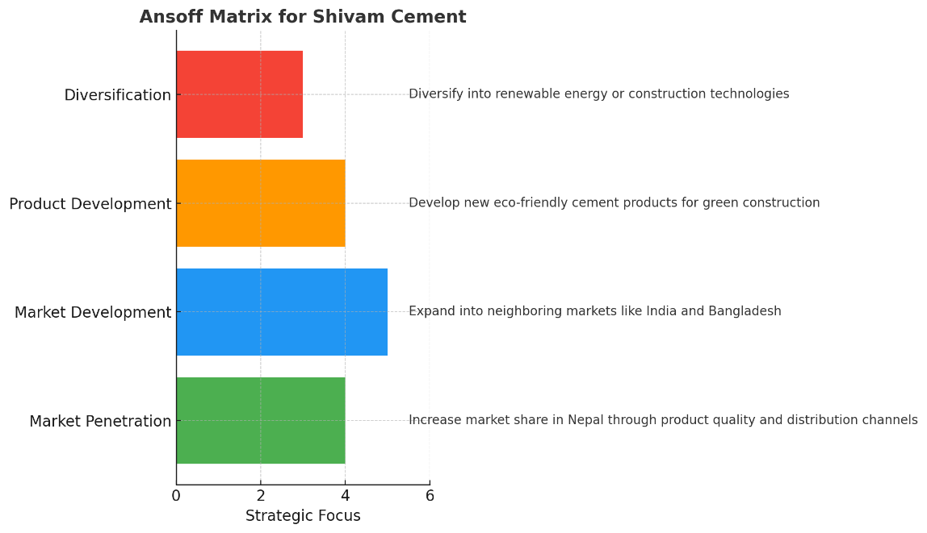
Figure 3: Ansoff Matrix for Shivam Cement
This bar chart will display the four growth strategies that would be identified in Ansoff Matrix that are of Market penetration, Market Development, Product Development, and Diversification of Shivam Cement. Adapted from (Santos et al. 2024), and (Viardot,, 2025).

5 LO4: Personal Leadership and Sustainability Perspective Reflection use only one transformational model you have applied more than this.
This part is a reflection of the leadership practices at Shivam Cement and the applicability of the practices to the concept of sustainability. It also talks about how this knowledge has contributed to my personal leadership development and how I will use sustainability in my future profession.

5.1Shivam Cement Leadership Insights
Shivam Cement has the management as the catalyst of the initiatives to sustain the company (Shivam Cement Ltd., 2024). The business leaders at Shivam Cement practice transformational leadership, where they are oriented towards the long-term goals of the environment and are motivated to promote positive change in the organization (Khalil and AbouZeid, 2025). Their dedication to green technologies including carbon capture and alternative fuels demonstrates how they deal with environmental issues and business performance, which is motivating employees and other stakeholders. Shivam has strong sustainability vision that is embraced by transformational leaders who inspire teams to embrace such innovations and participate in long-term ecological responsibility.
The concern with empowerment and ethical decision-making is another important characteristic of transformational leadership at Shivam Cement. Its leadership practices openness, transparency and accountability in its operations. This ethical management is at a high level establishes trust among stakeholders making sure that Shivam is having the reputation of being a responsible corporate party (Gerard et al., 2017). Shivam Cement has been able to cultivate the culture of embracing sustainability practices throughout the organization by creating an environment that has a culture of employees participating in the sustainability vision of the company.

5.2 Leadership Development on a Personal Level
The observation of how Shivam Cement has been led has made a great impact in my thinking in relation to leadership and sustainability (Shivam Cement Ltd., 2024). This has taught me that being a leader does not necessarily mean being focused on accomplishing business objectives but also being able to inspire others to work towards greater social causes and generate a sustainable environment (Santos et al., 2024). The sustainability of the people, planet, and profit integrative approach of transformational leadership by Shivam Cement has proved the value of the corporate success and sustainable development.
Engagement of stakeholders is also a focus of the leadership model of Shivam and this has helped me to understand the need to build a relationship founded on mutual trust (Shivam Cement Ltd., 2024). Constant communication with the local communities, the governmental bodies, and the environmental organizations help Shivam make joint decisions to ensure sustainable outcomes (Viardot, 2025). This understanding has had an impact on my leadership approach, and I would strive to serve as an example and involve others towards building a sustainable future.

5.3 Future Career Aspirations
Shivam Cement has been my role model in leadership that has had profound impact to my career goals (Shivam Cement Ltd., 2024). I would like to be employed in an organization where the sustainability aspect of the business is part of its core values. In my opinion, sustainable business practices are linked to improving the performance of corporations, as well as benefitting society (Santos et al., 2024). My future leadership style will establish a culture where employees are motivated to be environmentally friendly and embrace social equity, which will contribute to sustainability as one of my values.
The positive example of Shivam Cement ethical leadership and sustainability has demonstrated that leaders should not only be focused on their financial achievements but also make decisions that are beneficial to people and the environment. It is my ideal leadership style that I want to exercise in my career.

Conclusion
Shivam Cement can be viewed as an example of how the ethical decisions and sustainability can be integrated into the primary strategy of the company. I have been exposed to these practices and this has influenced my personal views about leadership and the need to focus on long term vision, stakeholder involvement, and social responsibility. I hope to make these values my guiding principle as I start my career in the field of sustainable business management and that environmental sustainability and ethical conduct will become my guiding principles, as I make decisions and take actions.

References
Abdulwadood, H.W., Hameed, R.S. and Mustafa, R.I., 2024, August. Assessing the environmental footprint of the cement industry: A pathway to sustainable development. In IOP Conference Series: Earth and Environmental Science (Vol. 1374, No. 1, p. 012017). IOP Publishing.https://iopscience.iop.org/article/10.1088/1755-1315/1374/1/012017/meta
Ahalawat, V., & Sethi, P., 2025. AI-driven environmental monitoring for sustainable cement production. Journal Global Value, 16(7), pp.13-27. https://anubooks.com/issue-view?id=145&key=ai-driven-environmental-monitoring-for-sustainable-cement-production-
Anchan, V., Manmohan, R., Agarwal, V. and Kaul, A., 2024. Challenges for the development of sustainable SMEs in the cement industry: a SWARA–WASPAS approach. Vilakshan-XIMB Journal of Management, 21(2), pp.248-262. https://doi.org/10.1108/XJM-11-2023-0232
CEMBUREAU, 2022. Statement on rising carbon prices and recent EU cement import trends. [PDF] European Cement Association. Available at: https://www.cembureau.eu/media/ptvg0yaq/cembureau-statement-evolution-of-carbon-price-and-cement-imports.pdf [Accessed 21 Nov. 2025].
ECIPE, 2022. The potential impact of CBAM: ECIPE Occasional Paper 04/2022. [PDF] European Centre for International Political Economy. Available at: https://ecipe.org/wp-content/uploads/2022/05/ECI_22_OccPaper_Defence_04_2022_LY10.pdf [Accessed 21 Nov. 2025].
EUR-Lex, 2022. Carbon Border Adjustment Mechanism: Summary of the regulation. [online] Available at: https://eur-lex.europa.eu/EN/legal-content/summary/carbon-border-adjustment-mechanism.html?utm_source=chatgpt.com [Accessed 21 Nov. 2025].
European Parliament Think Tank, 2022. Implications of CBAM for climate and competitiveness. [online] Available at: https://www.europarl.europa.eu/thinktank/en/document/EPRS_BRI%282022%29698889?utm_source=chatgpt.com [Accessed 21 Nov. 2025].
Financial Times, 2023. India criticises EU carbon border tax as trade barrier. [online] Available at: https://www.ft.com/content/40648adc-b621-41a3-958a-dd038c811986?utm_source=chatgpt.com [Accessed 21 Nov. 2025].
Gao, H., Wang, D., Zhao, Z., & Dang, P., 2024. Reducing carbon emissions in the cement industry using effective measures based on countries’ characteristics. PLOS ONE, 19(5), e0311859. https://journals.plos.org/plosone/article?id=10.1371/journal.pone.0311859
Gerard, L., McMillan, J. and D’Annunzio-Green, N., 2017. Conceptualising sustainable leadership. Industrial and commercial training, 49(3), pp.116-126.https://www.emerald.com/ict/article-abstract/49/3/116/105124/Conceptualising-sustainable-leadership?redirectedFrom=fulltext
Global Cement, 2024. Nepal Cement Manufacturers Association signs MoU for limestone calcined clay cement (LC3) technology. Global Cement News, 23 Jan. [online] Available at: https://www.globalcement.com/news/item/16854-nepal-cement-manufacturers-association-signs-memorandum-of-understanding-for-limestone-calcined-clay-cement-technology [Accessed 21 Nov. 2025].
Global Cement, 2025. CBAM: the Godzilla of carbon tariffs goes live. [online] Available at: https://www.globalcement.com/news/item/16394-cbam-the-godzilla-of-carbon-tariffs-goes-live [Accessed 21 Nov. 2025].
Ige, O.E., Von Kallon, D.V. and Desai, D., 2024. Carbon emissions mitigation methods for cement industry using a systems dynamics model. Clean Technologies and Environmental Policy, 26(3), pp.579-597. https://link.springer.com/article/10.1007/s10098-023-02683-0
Khaksar, E., Abbasnejad, T., Esmaeili, A. and Tamošaitienė, J., 2016. The effect of green supply chain management practices on environmental performance and competitive advantage: a case study of the cement industry. Technological and Economic Development of Economy, 22(2), pp.293-308.https://www.tandfonline.com/doi/abs/10.3846/20294913.2015.1065521
Khalil, E. and AbouZeid, M., 2025. Framework for Cement Plants Assessment Through Cement Production Improvement Measures for Reduction of CO2 Emissions Towards Net Zero Emissions. Construction Materials, 5(2), p.20.https://doi.org/10.3390/constrmater5020020
Kumari, G. and Joshi, Y., 2025. Holcim: building a green planet. The CASE Journal.https://doi.org/10.1108/TCJ-12-2023-0244
Marsh, A.T., Parker, R., Mdee, A.L., Velenturf, A.P. and Bernal, S.A., 2024. Inequalities in the production and use of cement and concrete, and their consequences for decarbonisation and sustainable development. Environmental Research: Infrastructure and Sustainability, 4(3), p.035002.https://iopscience.iop.org/article/10.1088/2634-4505/ad59c2/meta
Nawaz, R., Hussain, I., Noor, S., Habib, T. and Omair, M., 2020. The significant impact of the economic sustainability on the cement industry by the assessment of the key performance indicators using Taguchi signal to noise ratio. Cogent Engineering, 7(1), p.1810383.https://www.tandfonline.com/doi/full/10.1080/23311916.2020.1810383
Nepal News, 2024. MoU signed for environment-friendly cement production. Nepal News, 23 Jan. [online] Available at: https://nepalnews.com/s/science-technology/mou-signed-for-environmentfriendly-cement-production/ [Accessed 21 Nov. 2025].
myRepublica, 2024. MoU signed for environment-friendly cement production. myRepublica, 23 Jan. [online] Available at: https://www.myrepublica.nagariknetwork.com/news/mou-signed-for-environment-friendly-cement-production[Accessed 21 Nov. 2025].
Shakya, S.R., Subedi, S., Bajracharya, T.R., Shrestha, S.L., Sah, J.K. & Chaulagain, B., 2025. Sustainability Index for a Manufacturing Industry: A Case Study of Cement Industry in Nepal. Journal of Science and Engineering, 12(1), pp.37–48. https://doi.org/10.3126/jsce.v12i1.82361
Sandbhor, S., Apte, S., Dabir, V., Kotecha, K., Balasubramaniyan, R., & Choudhury, T., 2023. AI-based carbon emission forecast and mitigation framework using recycled concrete aggregates: A sustainable approach for the construction industry. AIMS Environmental Science, 10(4), pp.1-13. https://www.aimspress.com/article/doi/10.3934/environsci.2023048
Santos, K.F.D., Santos, S., Vieira, M., Santos Silva, A. and Pederneiras, C.M., 2024. Promoting Sustainability in the Cement Industry: Evaluating the Potential of Portuguese Calcined Clays as Clinker Substitutes for Sustainable Cement Production. Sustainability, 16(23), p.10365.https://www.mdpi.com/2071-1050/16/23/10365
Sharma, P., Ramachandra Rao, M., Mohapatra, B. N., & Saxena, A., 2021. Development of suitable machine learning model for a cement plant calciner. International Journal of Engineering Applied Sciences and Technology, 6(3), pp.30-45. https://ijeast.com/papers/194-198,Tesma603,IJEAST.pdf
Shivam Cement Ltd, 2025. About Us. [online] Available at: https://shivamcement.com.np/page/introduction[Accessed 21 Nov. 2025].
Shivam Cement Ltd, 2025. Certifications & Quality. [online] Available at: https://shivamcement.com.np/blogs[Accessed 21 Nov. 2025].
Tahat, I., 2023. Pricing strategy and firms profitability. SocioEconomic Challenges, 7(4), pp.124-132. Available at https://armgpublishing.com/journals/sec/volume-7-issue-4/article-11/
Time Magazine, 2024. US company captures CO2 from cement plants and makes cement. [online] Available at: https://time.com/7172596/ryan-gilliam/?utm_source=chatgpt.com [Accessed 21 Nov. 2025].
Times of India, 2024. Noida Airport uses low-carbon LC3 cement in construction. [online] Available at: https://timesofindia.indiatimes.com/city/noida/noida-airport-indias-first-to-use-low-carbon-lc3-cement/articleshow/124220299.cms?utm_source=chatgpt.com [Accessed 21 Nov. 2025].
Tsai, W. H., & Lin, W. H., 2024. Production decision model for the cement industry in pursuit of carbon neutrality: Analysis of the impact of carbon tax and carbon credit costs. Sustainability, 16(6), 2251. https://www.mdpi.com/2071-1050/16/6/2251
UNFCCC, 2023. Third National Communication (TNC) – Nepal. [online] United Nations Framework Convention on Climate Change. Available at: https://unfccc.int/sites/default/files/resource/TNC%20Nepal_Final_v2.pdf [Accessed 21 Nov. 2025].
Viardot, E., 2025. Concrete steps to cementing sustainability: Holcim’s environmental strategy. The CASE Journal, 21(3), pp.717-742. https://doi.org/10.1108/TCJ-05-2024-0161
Viswanathan, N.S. and Hajira, B., 2023. A Comparative Study of Market Performance and Effective Marketing Strategies of India Cements and Ramco Cements in the Cement Industry.https://doi.org/10.55529/jpome.37.5.11
Vorayos, N., Vorayos, N. and Jaitiang, T., 2020. Energy-environmental performance of Thai’s cement industry. Energy Reports, 6, pp.460-466.https://www.sciencedirect.com/science/article/pii/S2352484719310327
Wang, C.H., Chen, Y.C., Sulistiawan, J., Bui, T.D. and Tseng, M.L., 2021. Hybrid approach to corporate sustainability performance in Indonesia’s cement industry. Sustainability, 13(24), p.14039. https://doi.org/10.3390/su132414039
Wawaka, G.E., 2018. Effect of pricing strategies on competitive advantage of selected cement manufacturing firms in Kenya. Strategic Journal of Business & Change Management, 5, p.25. Available at https://dx.doi.org/10.61426/sjbcm.v5i2.731
World Resources Institute (WRI), 2024. How Blended Cement Can Lower US Cement Emissions. [online] Available at: https://www.wri.org/insights/lower-carbon-blended-cement [Accessed 21 Nov. 2025].
World Resources Institute (WRI), 2024. New US Projects Focus on Low Carbon Cement Technology. [online] Available at: https://www.wri.org/insights/low-carbon-cement-technology [Accessed 21 Nov. 2025].
Wu, Z., Shao, Z., Andrew, R., Bing, L., Wang, J., Niu, L., Liu, Z., & Xi, F., 2024. Global CO2 uptake by cement materials accounts 1930–2023. Scientific Data, 11(1), 1-10https://www.nature.com/articles/s41597-024-04234-8
Yosef, F.A., Jum’a, L. and Alatoom, M., 2023. Identifying and categorizing sustainable supply chain practices based on triple bottom line dimensions: evaluation of practice implementation in the cement industry. Sustainability, 15(9), p.7323.https://www.mdpi.com/2071-1050/15/9/7323

