Title Page

Executive Summary
Tesla, Inc. is a world-renowned manufacturer of electric automobiles (EVs) and renewable energy, as a company unique in its approach, having introduced a sustainable mode of transportation based on technological breakthrough and progressive vision. This is a strategic plan involving the integration of market, industry and financial analysis of Tesla to give it a detailed roadmap towards sustainable growth and worldwide competitiveness. The results show that the strengths of Tesla are its vertical integration, battery technologies, and financial stability whereas the threats are the increasing competition, the cost of production, and the lack of materials. The strategy focuses on increased production in the new markets, introduction of low-cost EVs to attract more customers, and the diversification of energy solutions to balance the revenue. An efficient implementation strategy and an effective monitoring system will make sure that Tesla does not lose its leadership and manages to meet the fast-changing industry of EVs. Collectively, these plans make Tesla a long term innovative, operationally excellent and profitable business.

Introduction
Tesla, Inc. is an international symbol of sustainability and innovation, which has been established by Elon Musk in 2003. By its quest to ensure the world becomes sustainable energy, Tesla has done more than turn the automotive industry upside down; it has transformed the entire world into having an enhanced view of renewable technology. The innovations of the company in battery systems, autonomous driving, and integration of clean energy have strengthened the leadership of the company in the electric car (EV) industry. This paper is a strategic plan that synthesizes the market, industry, and financial knowledge of Tesla into workable growth objectives. The emphasis is on matching the innovation with financial discipline and market expansion in order to maintain the leadership in the fast-changing industry. Drawing conclusions out of analytical results, setting specific goals, and designing a powerful evaluation system, this document will give Tesla a comprehensive approach to long-term competitiveness.
Market Analysis Integration
Environmental regulations, technological changes, and changing consumer tastes are contributing to the client base of the global EV market at an unprecedented pace. A sustainable mobility is the new reality as governments across the globe are providing incentives and imposing emissions limits that are favorable to the use of electric cars (Mutta & Soumya, 2024). Tesla has used its brand name and use of technology to lead in the market. Nevertheless, new entrants, particularly in Asia, are becoming increasingly dangerous due to their low cost and localization.
Its luxury targeting has continued to attract eco-conscious clients of Tesla, but the need to explore the middle-income markets is increasing. Tesla can also expand into low-cost markets and strategize regionally to expand into other markets, including India and Southeast Asia (Du and Li, 2021). Tesla will be in a position to improve its competitive advantage and meet the diverse needs of consumers through its low-cost, high-technology, and good online presence. To continue the momentum, Tesla ought to seek to improve the market-specific innovation, strategic localization, and cost optimization, which will ensure they fit in the consumer- and regulation-related expectations across the globe.
Industry Analysis Integration
EV business is an industry with fast progress, greater competition, and strict regulations. Established automotive firms are speeding up their investments in EVs, but new competitors like BYD and NIO have become notable forces with models that are affordable (Ingram, 2018). Such developments demand that Tesla innovates constantly and optimizes its efficiency in production. The vertically integrated business model of design, manufacturing, and software that the company has operates remains one of the key competitive advantages (Moritz et al., 2015).
The regulatory environment has been evolving extremely rapidly in which rules on emissions and the green power policies have enabled the use of EV. These transformations are aligned with Tesla, which manufactures the cars with zero emissions in an environmentally friendly manner that gives it a strategic advantage. It is however imperative that local environmental or safety laws be adhered to in the new markets. The company will remain on the top of the industry through further investment in autonomous driving, battery efficiency, and AI-based production by Tesla (Ingram, 2018). The trick to its long-term success will be such that it can create the optimal balance between the innovativeness and the affordability, but not to compromise its reputation of quality and sustainability.
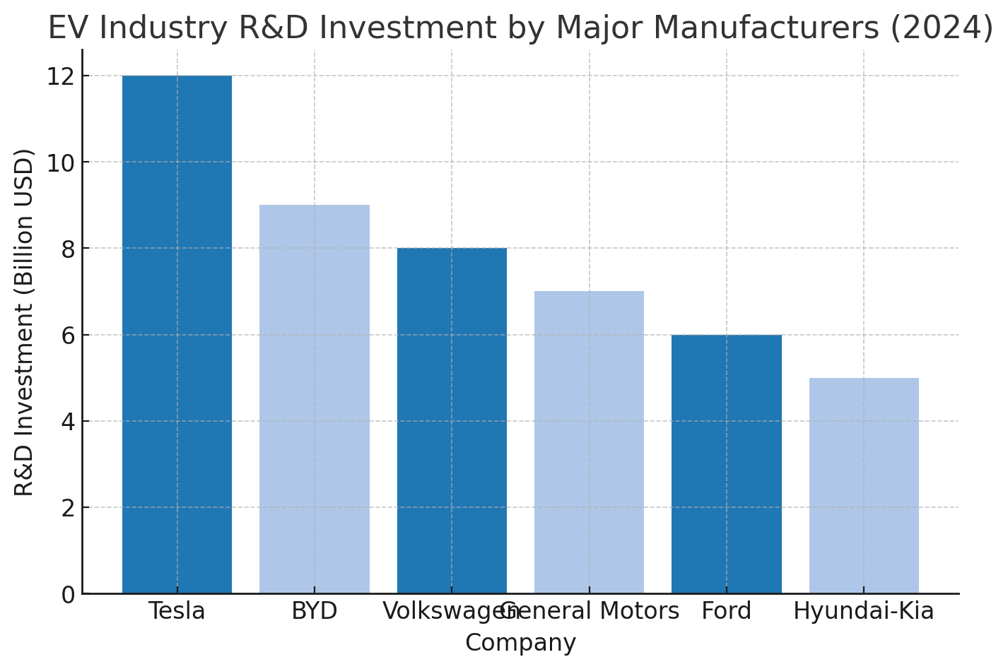
The chart illustrates that Tesla leads the EV industry in research and development (R&D) investment, allocating approximately $12 billion in 2024. This substantial commitment to innovation outpaces competitors such as BYD and Volkswagen, which invested around $9 billion and $8 billion respectively. The data reinforces Tesla’s strategic focus on maintaining technological superiority through advancements in battery efficiency, autonomous driving, and energy integration. Sustained R&D leadership ensures Tesla’s continued competitive advantage in an industry increasingly defined by innovation, performance, and sustainability.
Financial Analysis Integration
Tesla financial performance reveals that it has a steady growth, liquidity and the ability to make sustainable investments back into research and development. Its profitability, and liquidity ratios show that it has operated effectively and is stable financially to be flexible to execute expansion projects (Huang, 2023). The value and effective use of assets and value creation to shareholders are evidenced by good ROA and ROE ratios (Jencova et al., 2019).
However, Tesla will have to address external factors, such as the alterations in raw material prices and pressure on the production costs (Fang, 2024). The risks shall be mitigated through automation, supplier and vertical diversification. The Tesla solar panels and storage systems under the energy division create an additional source of revenue diversification as a strength in the times of fluctuation of the automotive market. An even-handed approach both regarding innovation spending and expenditure control will help Tesla to not only be profitable but also to hit strategic scale.
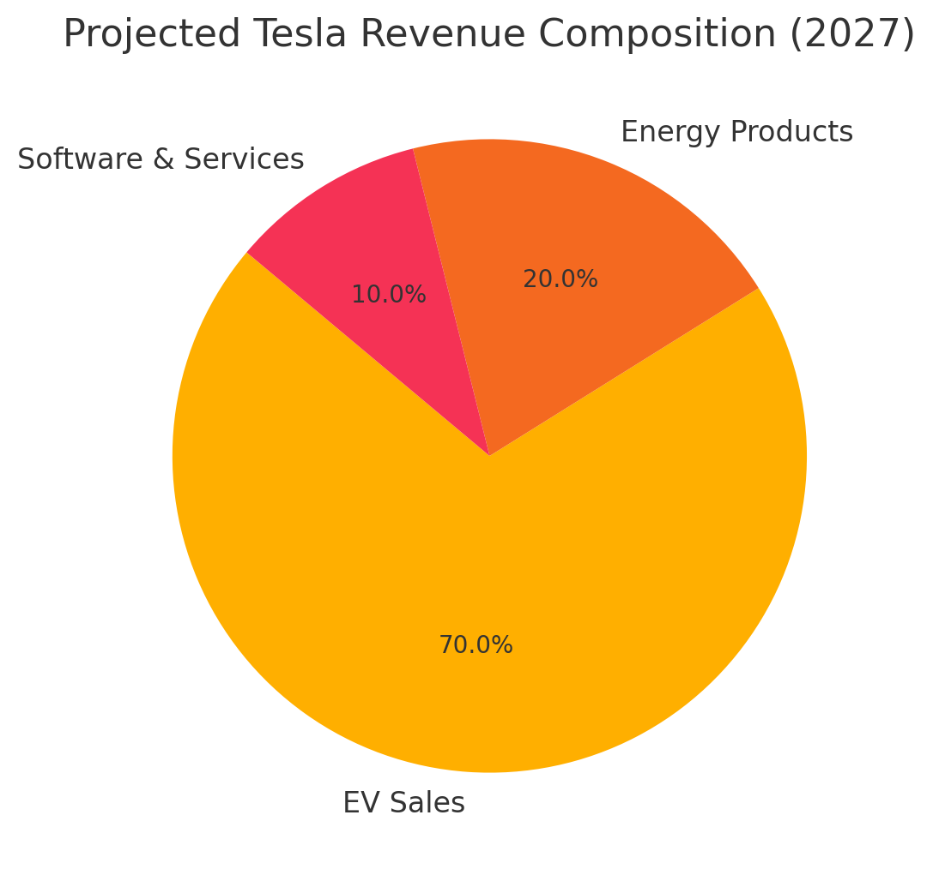
This visualization highlights Tesla’s progress toward a more balanced business model. While EV sales remain dominant, energy products and software services are projected to contribute 30% of total revenues by 2027, enhancing long-term stability and reducing dependency on automotive markets.
Strategic Objectives and Recommendations
The strategic plans at Tesla include market growth, cost-effectiveness, innovation and even diversification. These are supposed to render it sustainable over the long term and competitive position in the global market.
Tesla Strategic Objectives and Recommendations
Objective | Timeframe | Key Strategy/Action | Expected Outcome
Expand global production capacity | 2025–2026 | Build Gigafactories in India and Southeast Asia | +20% production capacity
Reduce production costs | 2025 | Implement automation and supply chain optimization | -10% cost reduction
Increase market share in Asia | 2025–2027 | Localize marketing, partnerships, and pricing | +15% regional market share
Launch affordable EV model | 2026 | Develop EV under $30,000 targeting middle-income consumers | New market penetration
Diversify revenue through energy products | 2027 | Scale solar and storage solutions globally | 20% total revenue contribution

The long-term strategic mission of Tesla is to achieve 25 percent of EVs in the world market by 2028 and expand its product lineup in renewable energy products. In order to achieve these objectives, one should invest in R&D, focusing on the efficiency of batteries and vehicle automation on the basis of AI (Hopkins and Lazonick, 2024). The improvement of the relation with the suppliers, the creation of strategic ties with the national government of the region and involvement into the local production policy will also contribute to the better control of costs and responsiveness. It is contrary to all these proposals that operational resources, technological resources, and financial resources of Tesla are aligned with sustainable growth and dominance in the world of EV ecosystem.
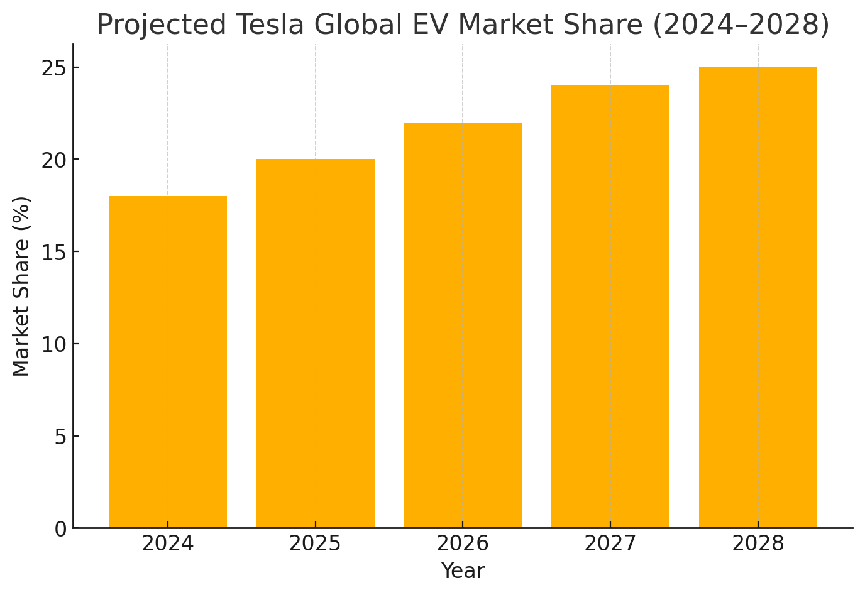
The data illustrate a steady increase in Tesla’s global EV market share, reflecting successful expansion into emerging markets and product line diversification. Achieving 25% market share by 2028 will depend on the effective execution of Tesla’s cost reduction and affordable vehicle initiatives outlined in the strategic plan.
Implementation Plan
Tesla implementation plan converts the strategic objectives into action plans that ensure that the objectives are developed on the basis of the measurable performance indicators. Each initiative is linked to specific schedule, tasks and KPIs.
Implementation Plan for Tesla’s Strategic Initiatives
Strategic Initiative | Timeline | Key Actions | Responsible Division | Key Performance Indicators (KPIs)
Global production expansion | 2025–2026 | Construct Gigafactories in India and Southeast Asia | Operations Division | +20% global output
Cost reduction | 2025 | Automate manufacturing, optimize logistics | Finance & Supply Chain | -10% cost per vehicle
Affordable EV launch | 2026 | Complete R&D, initiate global launch | Product Development | 200,000 units sold annually
Energy diversification | 2027 | Expand solar and Powerwall projects | Energy Division | 20% of total company revenue
Market share growth | 2025–2028 | Execute localized marketing and service strategies | Global Marketing | +25% global EV share

The coordinated performances of the departments will determine the success of Tesla and will be supported by the financial investments, human resources, and advanced technology (Hopkins and Lazonick, 2024). Regular audit of performance information and active management will be the driving force to make sure that Tesla remains focused on attaining its strategic objectives.
Monitoring and Evaluation
The monitoring and evaluation will be critical towards tracking the strategy and achieving successful implementation. Information analytics, real-time reporting, and feedback will constitute the basis of the adopted information analytics integrated performance management model in Tesla. The performance indicators will be implemented to evaluate the effectiveness of the production, cost per unit, the market share, the ROI, and also the sustainability. It will be a central data dashboard and it will inform the leadership on real time matters with the view of determining trends, inefficiencies and allocation of resources (Gadau, 2016).
Three tiers such as operation, tactical, and strategic are to be used in the monitoring. Operation monitoring will be conducted every month to take into account the factory output, supply chain performance and quality. Every quarter, a tactical review will be carried out, and also based on financial performance, market coverage and project development. Strategic reviews will be conducted annually on the general achievement of the goals, ROI and innovation achievements.
The predictive analytics will be able to predict the interruption of raw materials and the market needs in order to take corrective measures early. The accuracy of the decision-making will also be enhanced with customer satisfaction survey feedback, employee performance feedback and partner evaluation. A cross-functional task force will be directed by the Chief Operations Officer and analyze the performance data and make changes (Hopkins and Lazonick, 2024). This repetitive cycle of thought causes Tesla to be responsive enough to the market and at the same time manage to keep the company on the right path concerning the strategic goals. Continuous application and modification will assist Tesla sustain the growth, and retain the competitive potential in the world characterized by change.
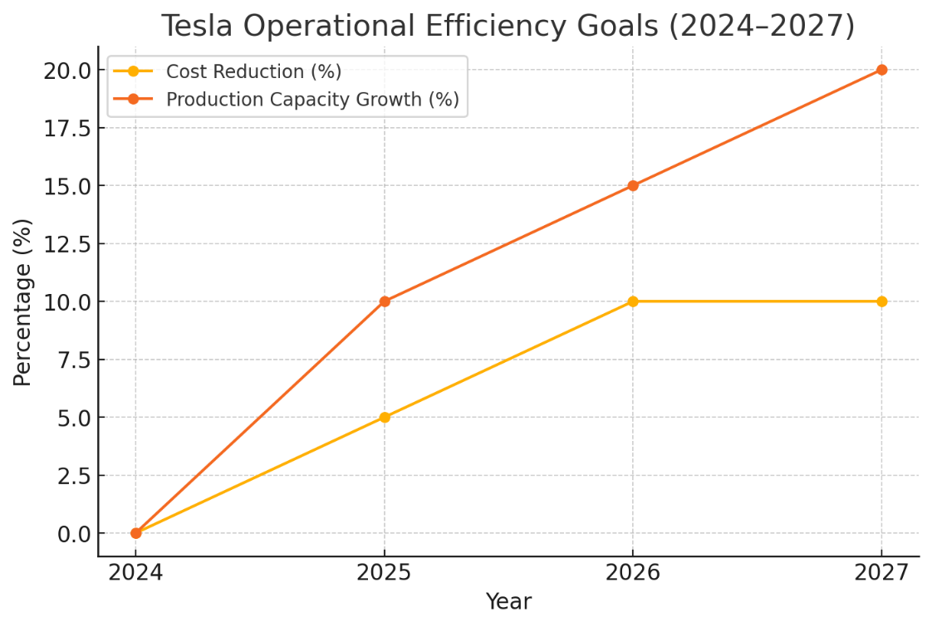
The line chart depicts Tesla’s dual-focus operational goals: a 10% reduction in production costs and a 20% increase in manufacturing capacity over the four-year period. These performance indicators form the foundation of Tesla’s monitoring and evaluation framework, ensuring consistent alignment with its strategic efficiency objectives.
Conclusion
Market and financial vision are the sides that Tesla prefers because it is a part of an overall strategic plan to realize the industry approach as the sole path to continuous innovation and growth in all places globally. Once the individual targeted are established (i.e. the improvement of the production capacity), the launching of the cheaper models and the, diversification of the energy solutions, the Tesla will focus the powers on the global EV and green energy market. The adaptable surveillance framework and the responsible practice of the company will ocularly guarantee that it can efficiently address the hazards that will emerge not solely but it will also be of quality operation. Tesla will also keep disrupting the automotive scene, as innovation, sustainability, and strategic foresight will help it do so; and ensure its place in the clean energy revolution.

References
Du, X., & Li, B. (2021, December). Analysis of Tesla’s Marketing Strategy in China. In 2021 3rd International Conference on Economic Management and Cultural Industry (ICEMCI 2021) (pp. 1679-1687). Atlantis Press. https://www.atlantis-press.com/proceedings/icemci-21/125966134
Fang, C. (2024). Tesla’s revenue forecast base on business model and financial statement analysis. In SHS Web of Conferences (Vol. 181, p. 02022). EDP Sciences. https://www.shs-conferences.org/articles/shsconf/abs/2024/01/shsconf_icdeba2023_02022/shsconf_icdeba2023_02022.html
Gadau, L. (2016). The Adaptation of Profit and Loss Account to the Current Requirements Reporting of the Performances. Annals of Spiru Haret University, Economic Series, (3). https://papers.ssrn.com/sol3/papers.cfm?abstract_id=2878035
Hopkins, M., & Lazonick, W. (2024). Tesla as a Global Competitor: Strategic Control in the EV Transition. Institute for New Economic Thinking Working Paper Series, (225). https://papers.ssrn.com/sol3/papers.cfm?abstract_id=4973602
Huang, W. (2023). Understanding Tesla’s Financial Strength: Analysis of Financial Reports and DuPont Analysis. Highlights in Business, Economics and Management, 6, 250-261. https://pdfs.semanticscholar.org/13d2/10f4a9e7d5c3806b1f364c066b5617a3823c.pdf
Ingram, N. (2018). Tesla Motors: A Potentially Disruptive Force in a Mature Industry. International journal of management and applied research, 5(1), 8-21. https://www.ceeol.com/search/article-detail?id=706937
Jenčová, S., Vasanicova, P., & Litavcová, E. (2019). Financial indicators of the company from electrical engineering industry: the case study of Tesla, inc. Serbian Journal of Management, 14(2), 361-371. https://aseestant.ceon.rs/index.php/sjm/article/view/15692
Moritz, M., Redlich, T., Krenz, P., Buxbaum-Conradi, S., & Wulfsberg, J. P. (2015, August). Tesla Motors, Inc.: Pioneer towards a new strategic approach in the automobile industry along the open source movement?. In 2015 Portland International Conference On Management Of Engineering And Technology (picmet) (pp. 85-92). IEEE. https://ieeexplore.ieee.org/abstract/document/7273032
Mutta, P., & Soumya, S. (2024). Unveiling the Landscape: A Deep Dive into the Electric Vehicle Industry and Key Player Analysis. Journal of Scientific Research and Technology, 43-47. https://www.jsrtjournal.com/index.php/JSRT/article/view/103

